# Module – 6 CloudWatch logs

**Assignment 2: To create an alarm to stop an idle instance and terminate an idle instance (Amazon EC2 console)**

To receive the alarm notification, we created notification topic and below are the steps

Step 1: Go to SNS service and create a ‘Topic’



Step 2: Configure below properties to create a ‘Topic’

1. Type: Select ‘Standard’
2. Topic Name: ‘m6assignment_alarm

Click on **‘Create topic’**.

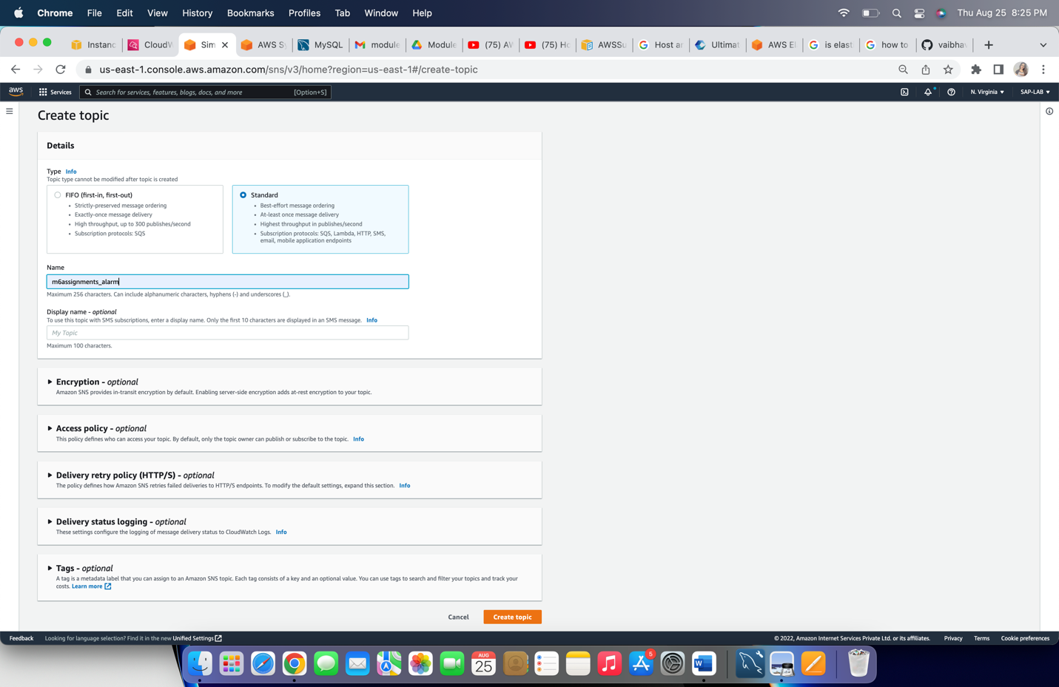

Step 3: click on **Create subscription**

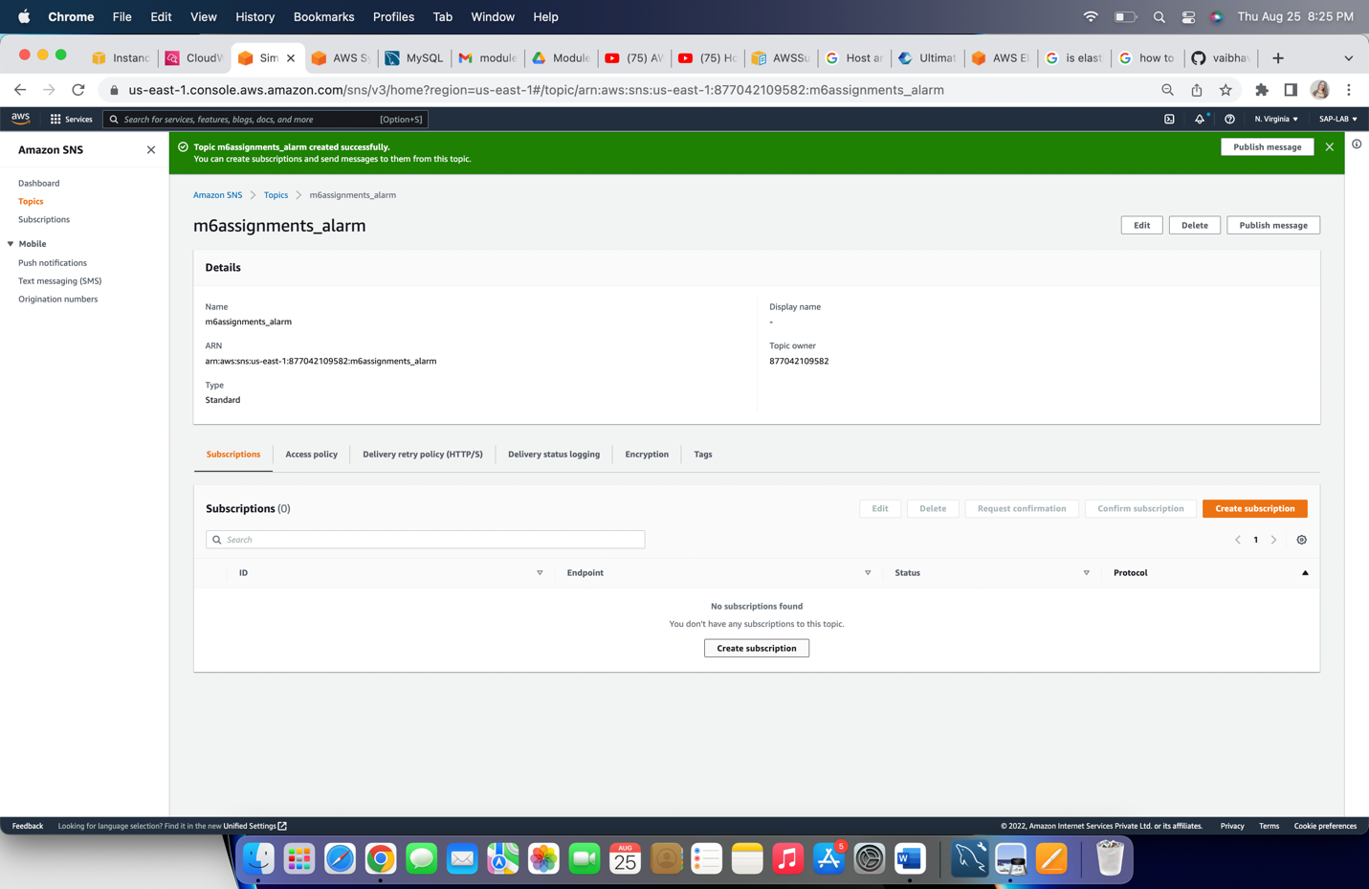

Step 4: Configure below properties to create ‘subscription’

1. Topic arn: Choose the topic arn
2. Protocol: Select ‘Email’
3. Endpoint: put the email to receive notification

Click on ‘Create Subscription’

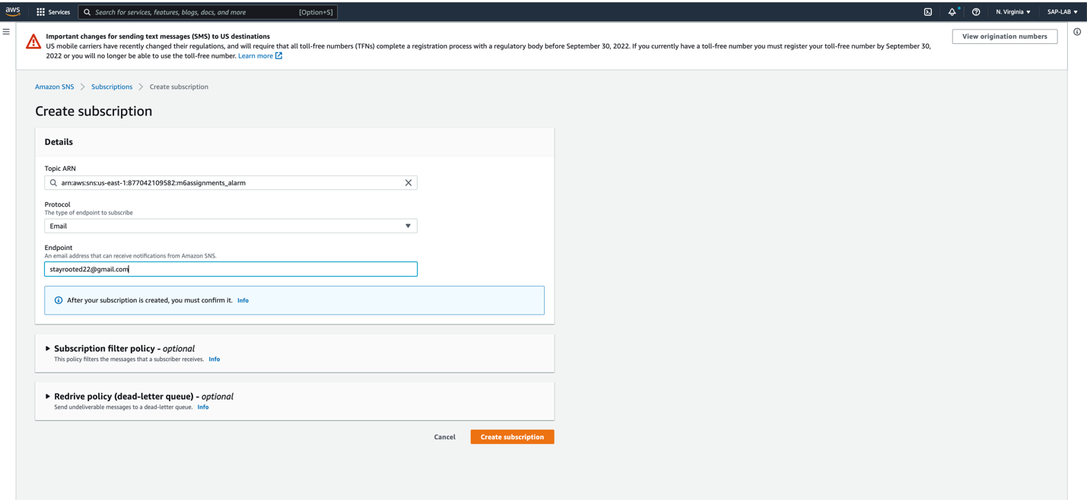

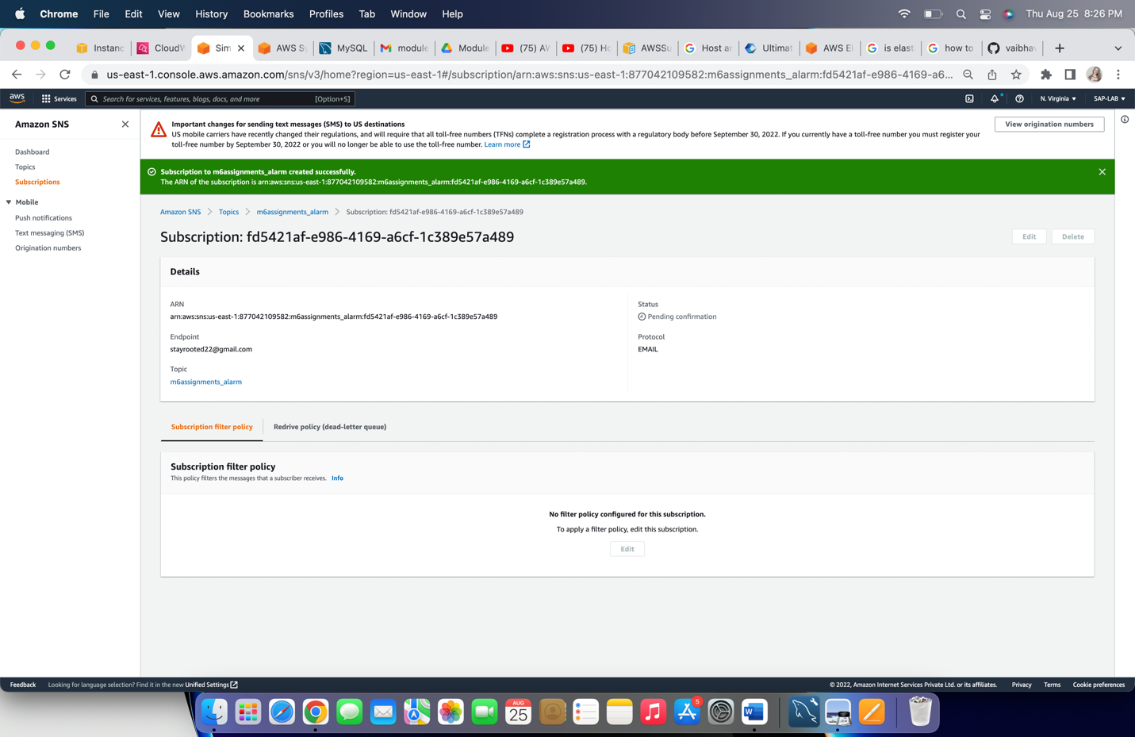

In the above snap, status is ‘Pending confirmation’, to confirm the subscription go to your mail account and confirm through received confirmation mail.

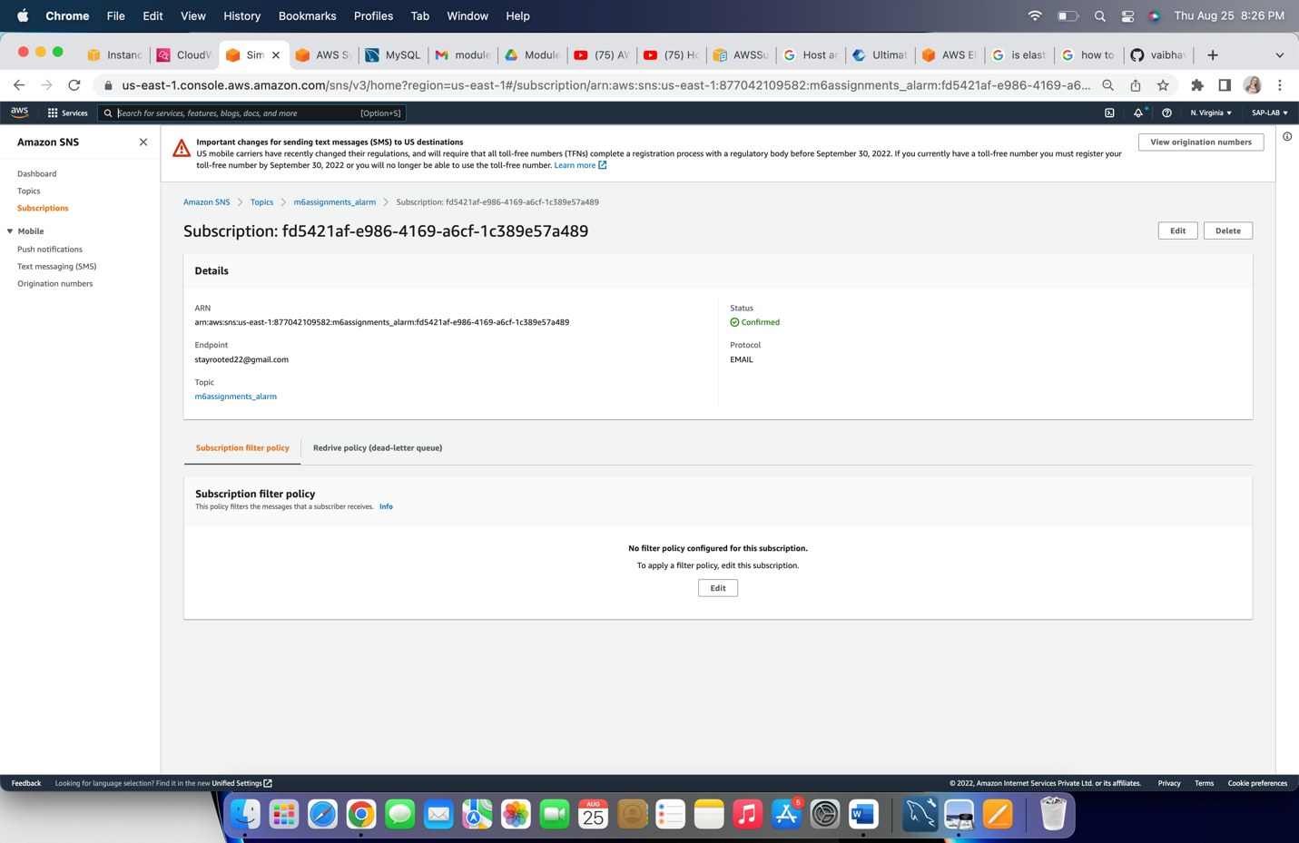

Step 5: Select instance, click on ‘Actions’ then ‘CloudWatch monitoring’ and click on ‘Add/Edit Alarm’.

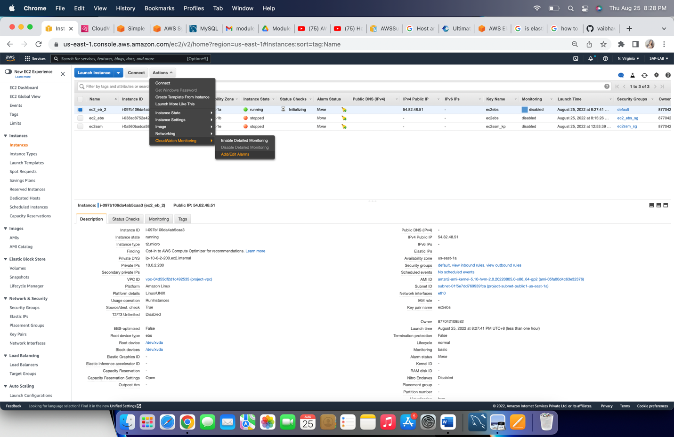

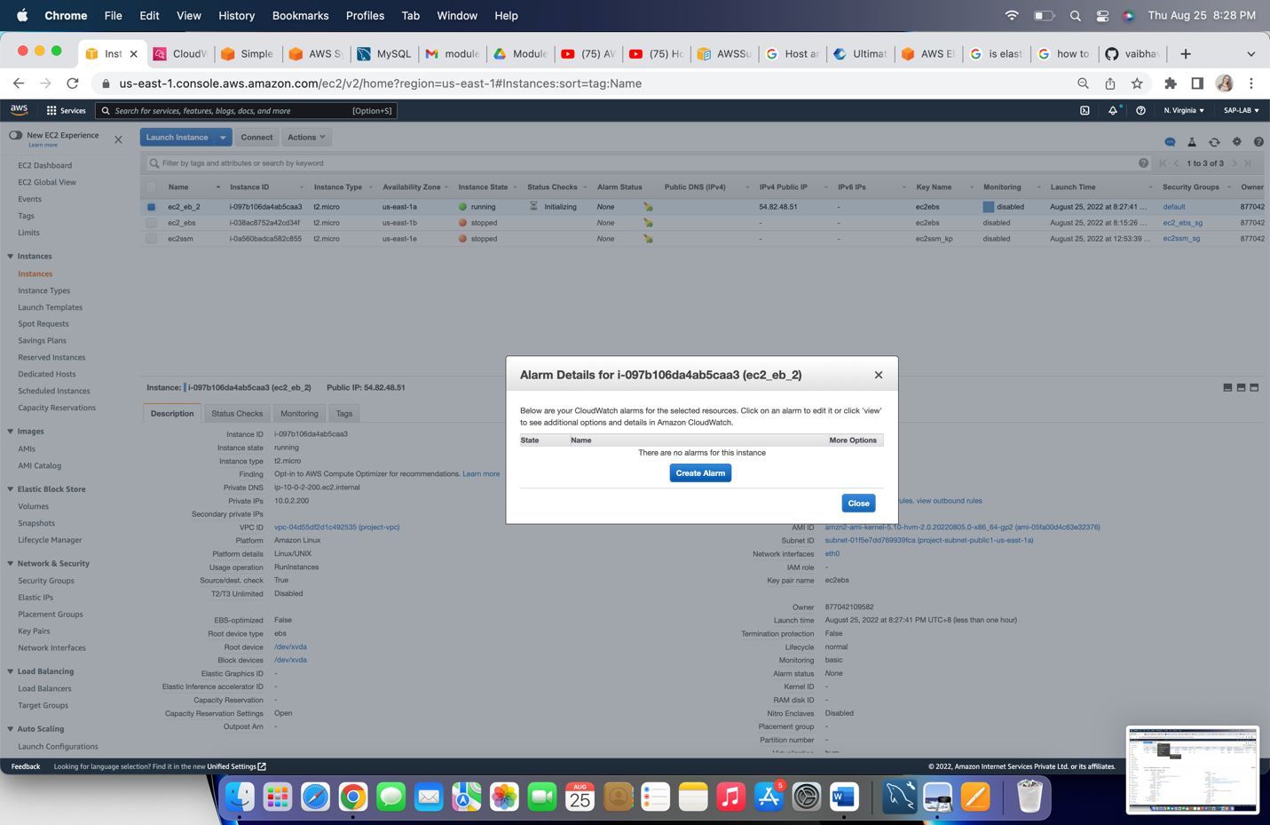

Step 6: Configure below details for alarm set-up:

1. Send a notification to: Select topic name created in above steps
2. Take the action: Choose ‘Stop this instance/Terminate this instance’
3. Whenever: Choose ‘Average’ of ‘CPU Utilization’ is ‘>=’ 0.01.
4. For at least: ‘1’ consecutive periods of ‘5minutes’
5. Name of alarm: Put the name for alarm

Click on ‘Create Alarm’

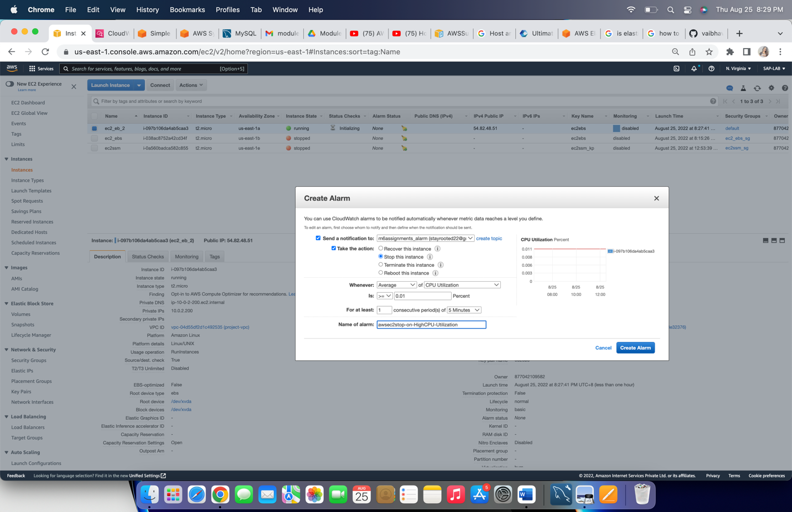

Go to CloudWatch logs dashboard, click on ‘All alarms’

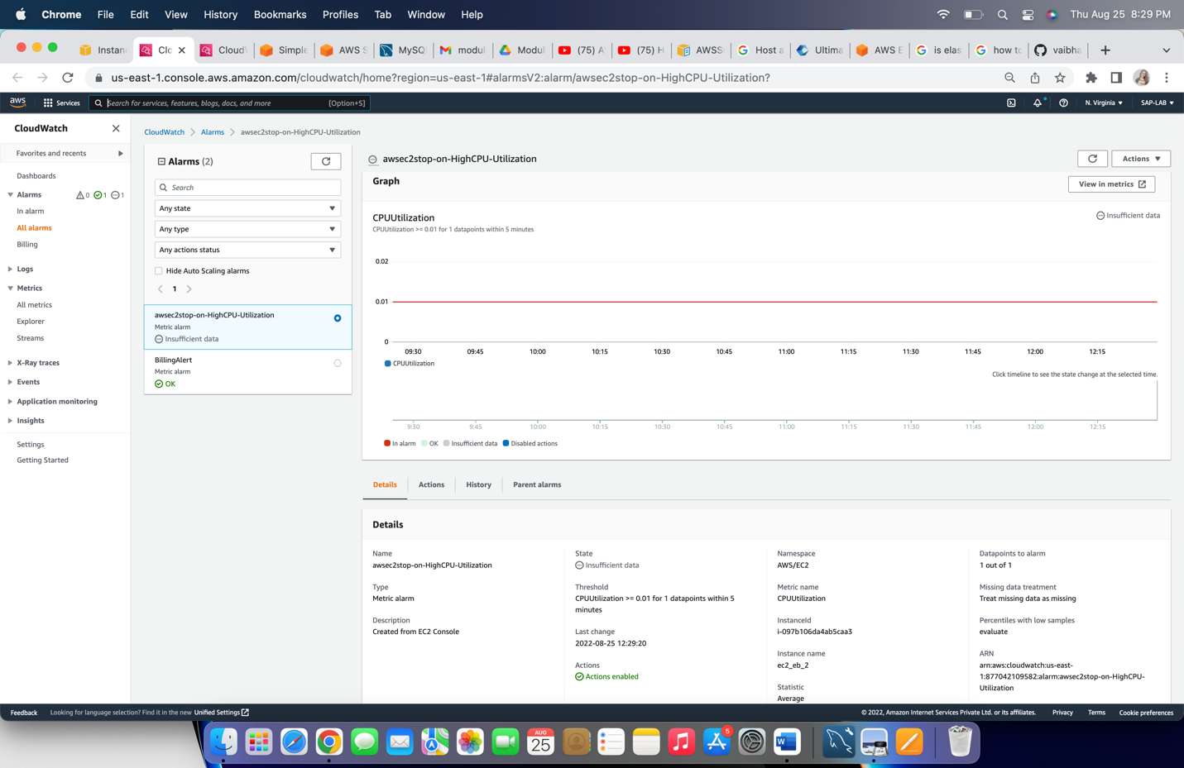

When ‘Stop’ alarm executes



When ‘Terminate’ alarm triggered

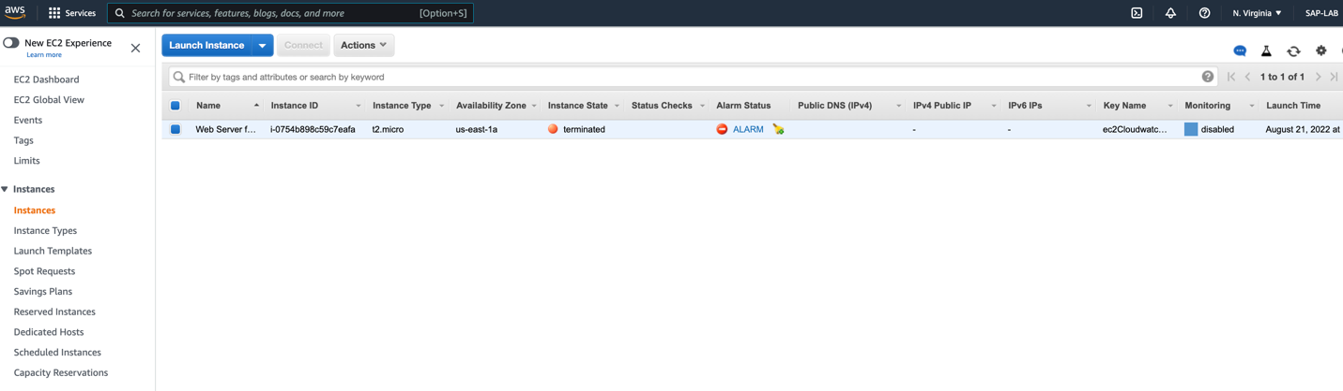

Instance will get stopped/Terminated once threshold reaches limit.